The Hart Museum is delighted to honor the *Woman Behind the Man* in a special display on our favorite cowboy movie star’s youngest sister, Mary Ellen. She was an integral part of his life, and she shared the retirement home, *La Loma de los Vientos*, with her famous brother, but as guests see when they visit every day: Mary Ellen’s bedroom is technically closed and not part of the public tour. Therefore, we are excited to highlight Mary Ellen’s own personal affects, none of which are normally on display, in an attempt to get to know her just a little better.

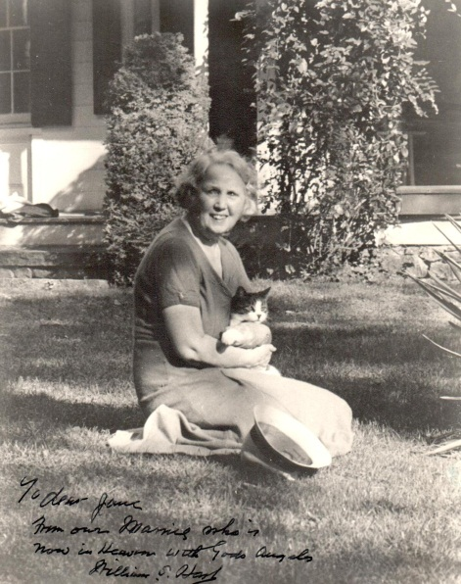 Because who was Mary Ellen Hart?

Well, records being what they were in the late 1800s, her date of birth is somewhat contested. It was long believed she was born in 1878 but a recent review of the 1880 Federal Census indicates that she may have been born as early as 1872 (she is listed as being 8-years-old at the time of the 1880 Census).

According to her death certificate, Mary Ellen was born in Aurora, Illinois — one of the many small “Western frontier” towns Bill and his family briefly called home throughout the course of the early 1870s. The youngest of the Hart children, she technically grew up in Newburgh, since the family returned to the sleepy New York town around 1876, and then attended Hunter College in New York.

*Bill Hart’s sister, Mary Ellen sits on the lawn holding her beloved cat, Westport Pouffins. Friend and artist James Flagg used this photo to create the beautiful oil currently on display in the Hart Mansion Living Room in 1945. This copy of the photo includes an inscription from a devastated Bill — it reads, “To Dear Jane, From our Mamie who is now in heaven with God’s angels. William S. Hart.”*

When the Hart patriarch, Nicholas, passed away in 1895, responsibility and care for the family fell to the only surviving son, 30-year-old Bill Hart. It appears that Bill’s older sister, Frances, might have been married by this time, so Bill became responsible for his unmarried younger sister, Mary Ellen, and his now-widowed mother.

It is not clear when Mary Ellen assumed the full-time care of her sickly mother, Roseanna, but, according to a 1943 article in the *Newhall Signal*, Bill relayed at Mary Ellen’s funeral that she “gave up the one great romance in her life during her early womanhood to take care of their mother.” Did this broken romance occur around the same time as Nicholas’ death? It is open to conjecture.

Either way, Mary Ellen became caretaker while her brother became the “breadwinner,” and while caring for a sick mother was a full time job, Mary Ellen was not idle. She wrote short stories — several were published in pulp magazines in the early 1910s and then, in partnership with her brother, they were published in book format through the 1920s and 1930s.

Then, Roseanna passed away in 1909, and the now 30-something Mary Ellen remained with her brother in the home they shared in Westport, Connecticut. 1914 saw the move to Hollywood and a still-not-idle Mary Ellen continued her writings while also supporting her brother’s blossoming film career. Bill Hart stated in a 1919 newspaper article that Mary Ellen was his “closest advisor” during these days — it is reported she helped him with story development and screenplays at the very least.

In 1917, tragedy struck when Mary Ellen was involved in a serious car accident while traveling out to one of Bill’s film sets. Sources vary as to the extent of her injuries, but it appears she did crack a vertebrae in her neck, and, as is seen on display in the hallway to her bedroom, she relied partially on a wheelchair for the rest of her life.

The early 1920s saw the gradual transition from Hollywood to Newhall, and when construction planning started on the dream retirement home in the mid-1920s, Mary Ellen was deeply involved.

*In this undated photograph, Mary Ellen is seen here behind the wheel with one of the Harts’ beloved English bulldogs (possibly Mack) in the back seat. Your Corny Coordinator’s thoughts? If that is Mack, he sure doesn’t look happy to be stuck in the back seat!*

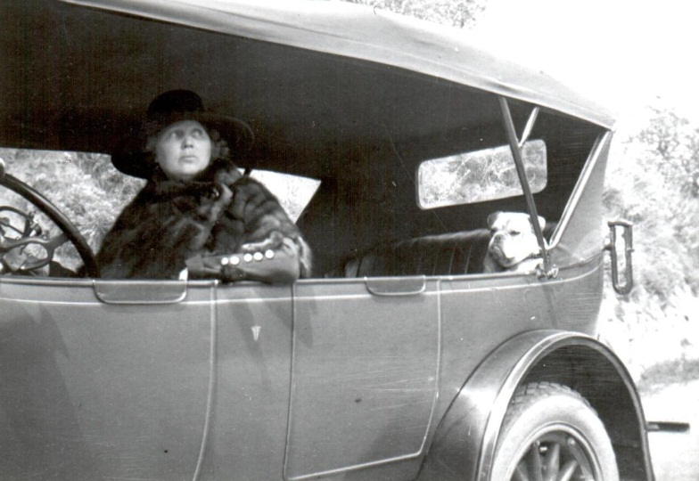Notes from architect Arthur Kelly relay Mary Ellen’s requests:

Mary Ellen is an invalid and has to have a large, airy bedroom, with a fireplace, and big bathroom and dressing room. Her bedroom wants to be placed so that it has a good exposure and plenty of air.

Interestingly, the original plans for the home appear to have called for 3 bedrooms — one for Bill, one for Mary Ellen, and one “will be a guest’s room or possibly a nurse’s room, if Miss Hart requires a nurse.” (undated notes from Kelly’s files). This intention may explain why the Hart Mansion’s Guest Wing, which is very much part of the public tour, has the look and feel of a private apartment.

*In this undated photograph, Mary Ellen is seen here behind the wheel with one of the Harts’ English bulldogs (possibly Mack) in the backseat. Somebody doesn’t look too happy being stuck in that backseat either.*

*In this undated photograph, Mary Ellen is seen here behind the wheel with one of the Harts’ beloved English bulldogs (possibly Mack) in the back seat. Your Corny Coordinator’s thoughts? If that is Mack, he sure doesn’t look happy to be stuck in the back seat!*

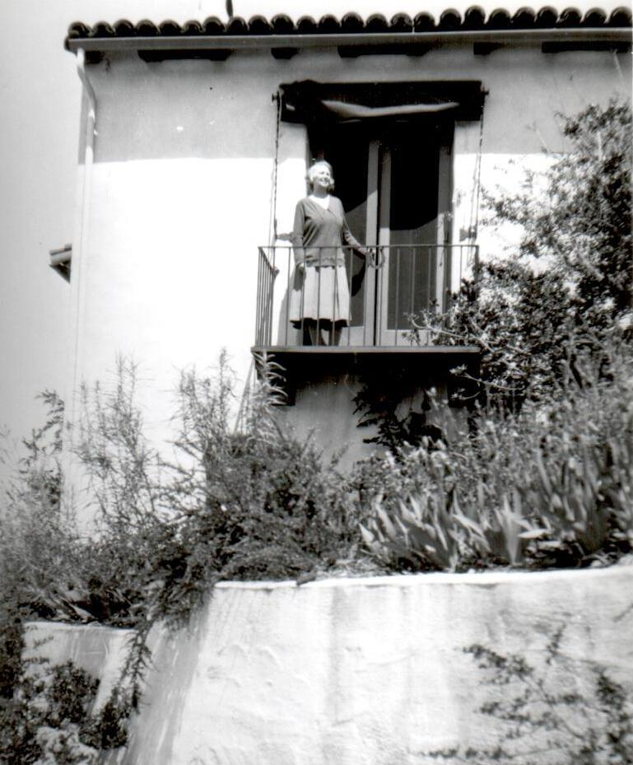

And when *La Loma de los Vientos* was completed in 1927, Mary Ellen’s requests were all fulfilled — her large bedroom on the front corner of the home features 2 closets, a bathroom, a fireplace, and 2 balconies, including a beautiful Monterey-style wood balcony seen from the front drive.

*In this undated photograph, Mary Ellen is seen here behind the wheel with one of the Harts’ beloved English bulldogs (possibly Mack) in the back seat. Your Corny Coordinator’s thoughts? If that is Mack, he sure doesn’t look happy to be stuck in the back seat!*

*In this undated photograph, Mary Ellen is seen here behind the wheel with one of the Harts’ beloved English bulldogs (possibly Mack) in the back seat. Your Corny Coordinator’s thoughts? If that is Mack, he sure doesn’t look happy to be stuck in the back seat!*

And by all accounts, Mary Ellen’s years after she moved into the mansion were quiet and secluded. She was known to spend a great deal of her time out on the lawns, in her bedroom, or in her tea room reading and writing — her last collaboration of stories with her brother, And All Points West, was published in 1940. When William S. Hart, Jr., paid a visit to the Hart Museum in the early 1990s, he shared some memories of his aunt, including recollections that “there was always a book in her hand,” and “once a year, Mary traveled by private rail car to New York City where she stayed on the top floor of the Hotel St. Pierre.” (notes from Hart staff on Bill Jr.’s visit).

*A smiling Mary Ellen stands on the side balcony off her bedroom in the Harts’ Newhall mansion (now the Museum). The beautiful Monterey-style balcony seen on the front of the Hart Mansion was also for Mary Ellen’s private use.*

Another favorite destination for Mary Ellen during these twilight years was Santa Monica. She purportedly traveled down there and stayed in the Miramar Hotel during the blisteringly hot summer months in Newhall, and it was here, in the Miramar, that she passed away on October 1, 1943 after suffering from what appears to be a stroke. Her death certificate lists her age as 64, but if she had been born in 1872, she would have been closer to 71.

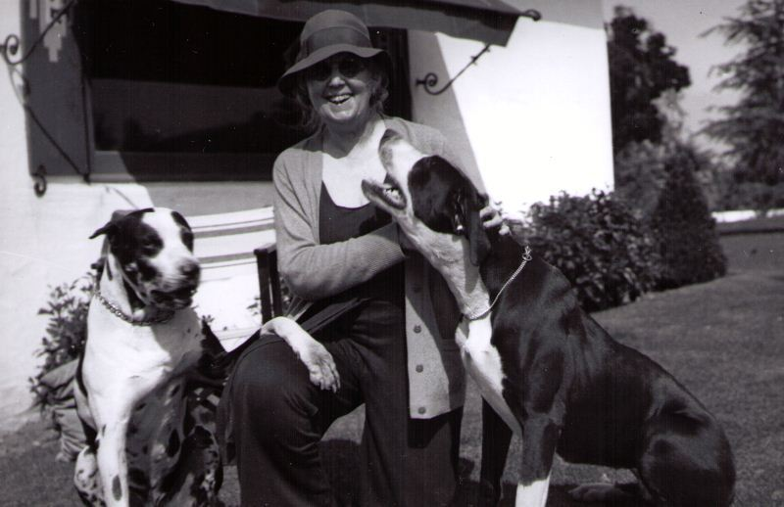Interestingly enough, Mary Ellen had her own estate, and according to an undated article in the *Newhall Signal*, Mary Ellen had drafted a series of suggestions for the division of her assets at her death. She wanted to set aside monies for the maintenance of the museum and park in Newhall (which indicates Bill Hart had planned to convert the Horseshoe Ranch into a public park and museum before Mary Ellen’s passing) as well as money for the maintenance of the Hollywood house.

*Mary Ellen is all smiles and surrounded by “puppy love” in this undated photo. Two of the Harts’ Great Danes flank her as she kneels on the lawn outside the Hart Mansion. An avid animal lover like her brother, Mary Ellen left money for the establishment of an animal shelter in Westport, CT. That shelter still exists to this day!*

One of her enduring legacies is the money she left for the establishment of an animal shelter in Westport, Connecticut. That shelter, the Westport Shelter, is still in existence today as part of the Connecticut Humane Society, and Mary Ellen’s photo still hangs inside!

Today, the Hart Museum is excited to honor Bill Hart’s rock and devoted companion in a special display of Mary Ellen’s personal possessions. A woman of soft features and flowing red hair (according to Bill Jr.,), one case highlights Mary Ellen’s incredible collection of perfumes and costume jewelry. Her love of writing is seen in the second case, which features her personalized stationery, writing implements, and inkwells, and her love of animals — and one animal in particular — is seen in the final case with a collage of photos and a handwritten poem dedicated to the beloved cat, Westport Pouffins.

And you will not want to miss the beautiful portrait of Mary Ellen executed by artist Bill Arnold in 1944. Usually hanging above the fireplace in Mary Ellen’s bedroom, this softly-toned painting is now hanging on the wall just to the left of the telephone booth in the Mansion. A bust portrait, it captures Bill’s beloved sister as a young woman.

Bill himself was overcome with emotion when he saw the painting, as he described in a July 1944 letter to the artist:

I could only stand and shake, as one with the ague. My darling sister stood before me, vibrant with life, actually living. — I can say no more.

Some may recognize the name Bill Arnold because, yes, he is the same artist who painted the portrait of Bill Hart currently hanging in the hallway between Mary Ellen’s room and the Dog’s Bedroom — the portrait dedicated to the memory of Bill Hart’s good friend, Charles Russell.

So if you get the chance, be sure not to miss these incredible artifacts not usually on exhibit. And the Hart Museum hopes you enjoy learning some more about Bill’s beloved sister, Mary Ellen.